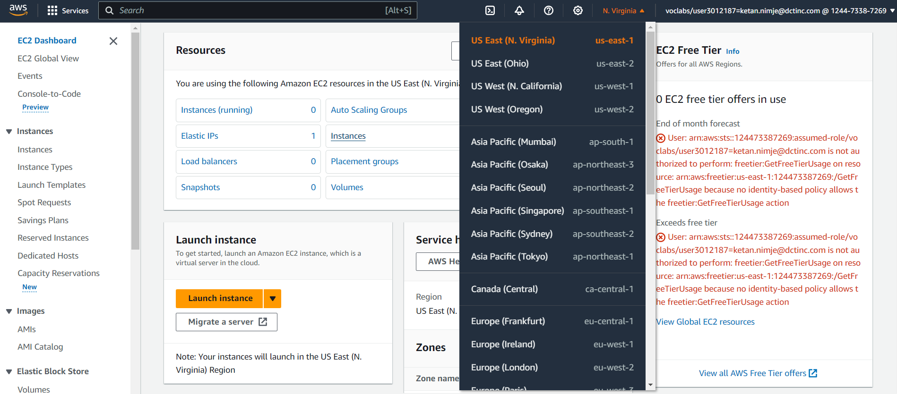

1.To understand the process of setting up and managing an Amazon EC2 instance.

Choosing the location as US East.

Launching the EC2 Instance

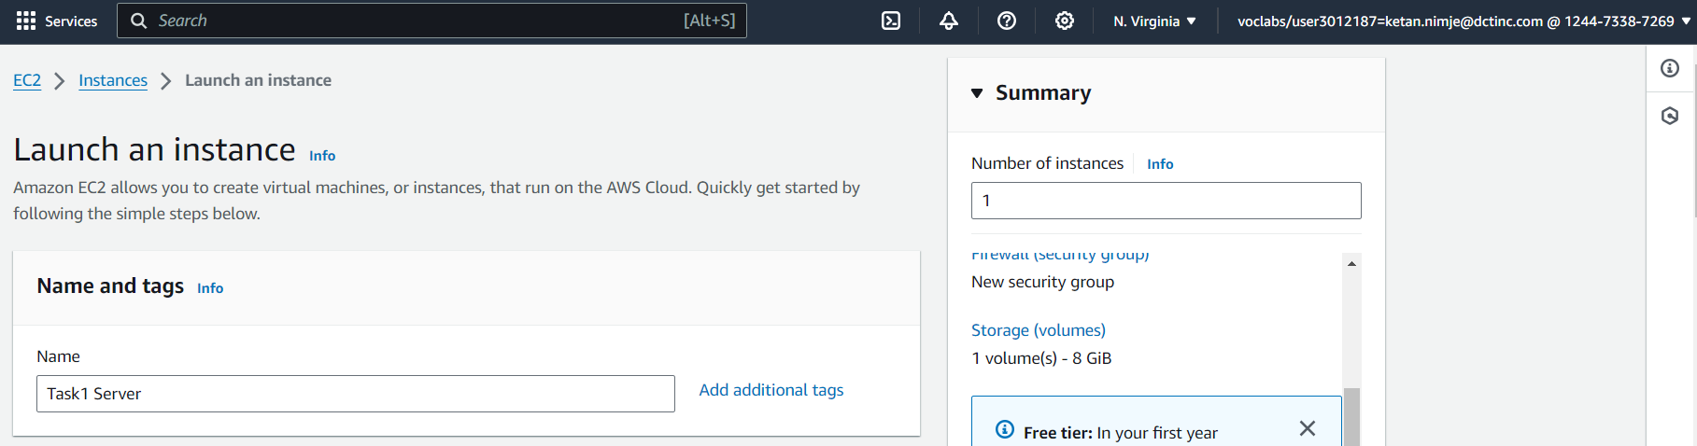

Set the instance type, instance configuration, architecture and create key pair.

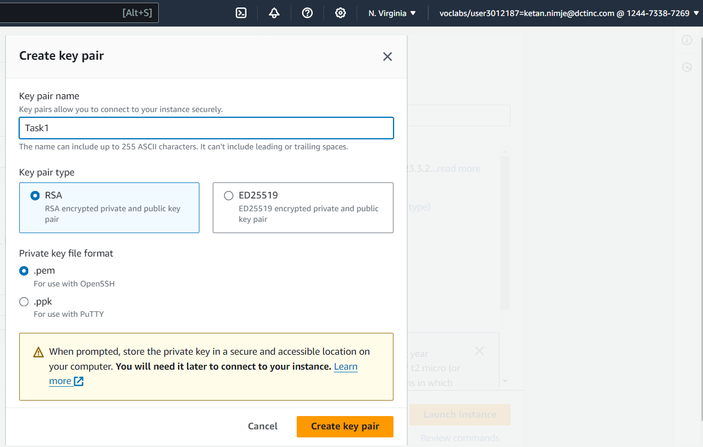

The instance is created and it is in running state.

Allocating Elastic IP and then associating it to the instance

Select the network border group

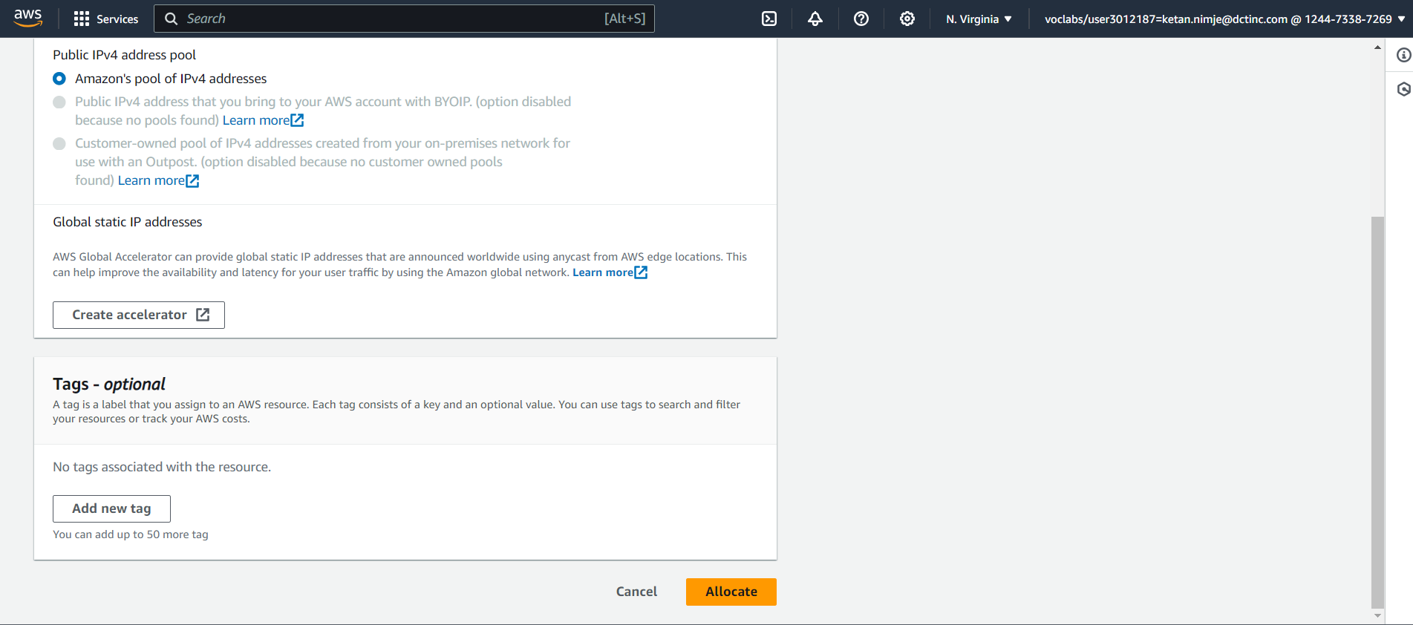

Select the resource type, instance id.

Now connecting the instance to SSH shell

Open terminal (command prompt in windows) in the folder having key pair.

Give the command -> ssh -i <name of pem file> <username>@<IPv4 Public DNS> or copy the whole command as shown in the window above.

After completing the task terminating the EC2 instance in the instance state tab.

2.To gain hands-on experience with Amazon S3 by performing basic storage operations.

Specify the aws region, bucket type, bucket name, object ownership. Uncheck the block all public access to enable the public access to bucket.

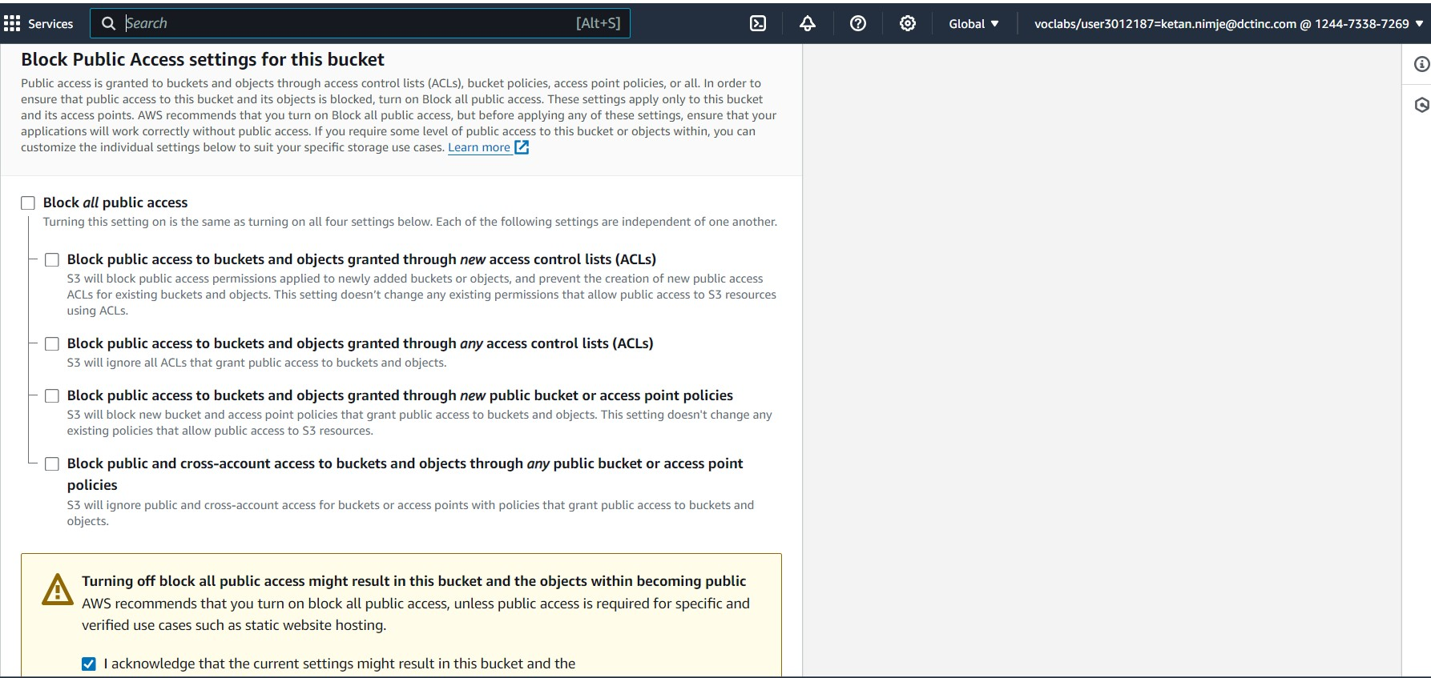

S3 Bucket is created. Now insert the file in the bucket which will be created as an object using the aws user interface.

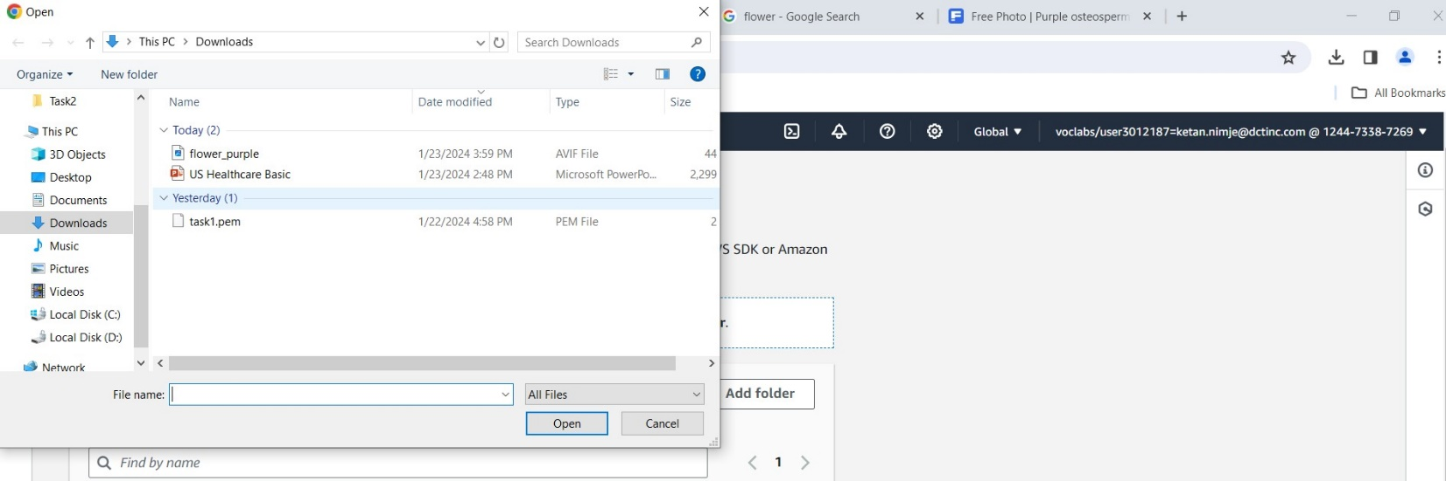

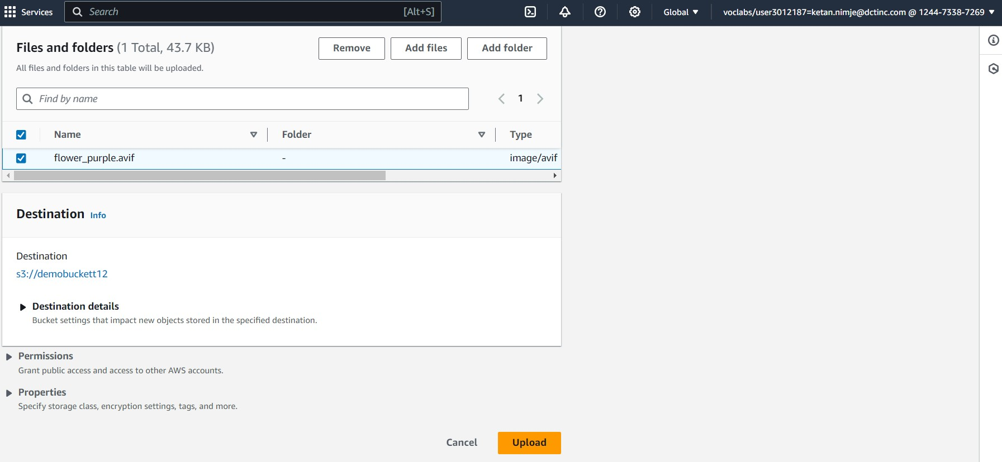

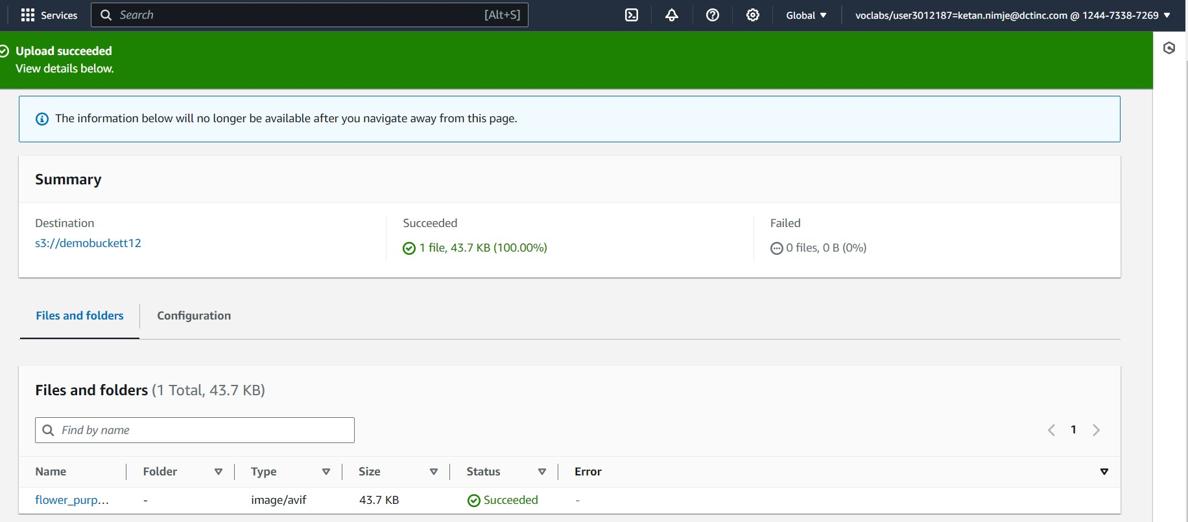

Object flower_purple is created.

After the file is uploaded as an object, make the object public to be able to access it on internet using the object URL.

Clicking on the object URL, we will be able to access the file on internet. Below shown image is the file uploaded. Then deleting the object and the bucket using the aws user interface.

